The Case of the Kelly Gang

Using fingerprints to solve a crime

Alison Graham
Teachers notes
The case of the Kelly Gang
____________________________
Syllabus links:
Syllabus aims and objectives
Skills:
- observation, measurement and the accurate recording of data
- manipulation of data in a variety of forms, including graphs
- logical thinking, inductive and deductive reasoning, formation of opinions based on evidence and experiment

Equipment required:
Ink pad

What you need to do in advance:
Photocopy student sheets
On the first lesson get some students to do 2 versions of fingerprints

For second lesson
photocopy one of these as the prints collected from Urschel, they will then match with one of the students sheets.
You could either allow students to move around the room comparing prints
or photocopy a dozen for students to compare to find the farm cup with Urschel’s prints on it.

Expected results:
One of the prints from the farm cups ( the students’ prints) will match those of Urschel

Suggested answers to questions:
On fingerprints:
- Probably not exactly
- Variation in the population, typical of all biological populations, due to sexual reproduction. Very important not to be genetically identical- eg resistance to disease
On Urschel kidnapping

- This depends on whose you used as the fingerprints from the cup.
- Evidence on the number and order of whorls, loops and arches
- Trace evidence: threads of fabrics from Urschels clothes etc in the barn, and in the car used to move him
Evidence on movements of suspects from neighbours etc

What actually happened

When shown the farm where the Kellys lived Urschel could identify it as his place of capture and his fingerprints were found over all surfaces within his reach.
The Kelly gang was rounded up and one of them was in possession of some of the marked bills paid over as ransom. They were given long jail terms. It emerged that George ‘Machine gun’ Kelly was actually a rather reluctant gangster who had never fired a gun in anger and his notoriety was almost entirely due to his wife’s stories about him. He spent the rest of his life in jail.
Student worksheet
The Case of the Kelly Gang
The crime

On the evening of July 22nd a card game between Oklahoma City oil millionaire Charles Urschel and his wife and their friends, the Jarretts, on the patio of the Urschel’s home was interrupted by the sudden appearance of 2 gunmen. ‘Which one of you is Urschel?’ snarled one of the bandits. When neither man responded, both were forced into a car and driven off. Although ordered not to do so Mrs. Urschel called the police. Within 2 hours Walter Jarrett was back at the Urschel house, shaken after being pushed from the car when his identity had been sorted out by the kidnappers.
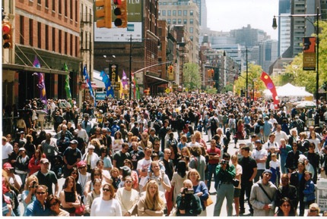
Four days later a ransom note was received with a demand for 100,000 dollars. If they agreed to the terms the family were told to put an advert in the Daily Oklahoma reading ‘For sale- 160 acres land, good 5 bedroomed house Box H807’. They did so and another family friend was approached with details of where to hand over the money in a crowded street. A day later Urschel returned home exhausted but unharmed.
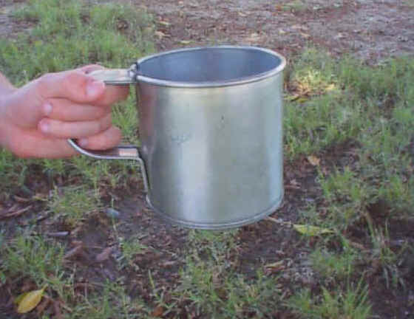
Urschel had been kept blindfolded but was very observant- he was able to tell police that he had been kept on a farm, where the water tap rattled and he had the presence of mind to leave good fingerprints all over the tin cup from which he was offered water. After a day or so his blindfold loosened enough for him to see his watch and he was able to tell police that a plane flew over the farm at exactly 9.45 each morning, and 5.45 each evening. Also the day before his release there had been a downpour and he heard no plane in the morning.
What you need to do to solve the crime!

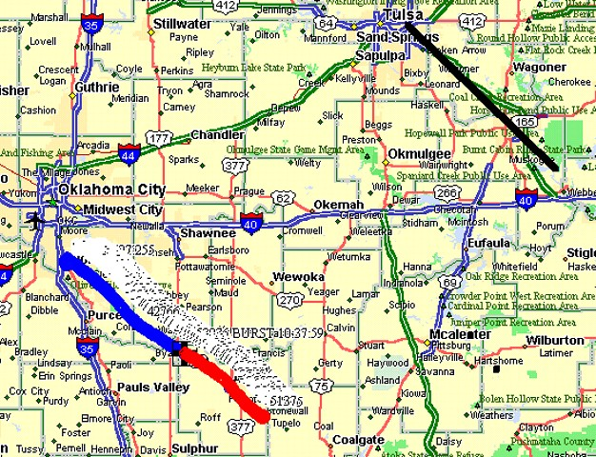
The efforts of the police centred on the rainstorm and the cancelled flight. All airlines that flew within a 600 mile radius of Oklahoma City were contacted for details of their schedules.
American Airlines reported that a plane had been forced to swing north to avoid a heavy storm. Calculations showed that the morning and afternoon flight would pass over Paradise, Texas at approximately the times given by Urschel.
The police visited every farm in the area and posing as bankers seeking to extend loans to farmers so as not to arouse suspicion collected fingerprints from all the tin cups which most farms kept beside the well for workers to drink from in the hot climate.

You are supplied with fingerprints from the tin cups at the wells of a range of farms in the area. Are Urschel’s fingerprints on any of them?

What have you found out?
- Which farm was the one with a cup with Urschel’s fingerprints on it?
………………………………………………………………………………………
- How sure are you? Explain how you arrived at your conclusion.
……………………………………………………………………………………………………………………………………………………………………………………………………………………………………………………………………………
- If you were in charge of this investigation what other evidence would you need to collect to back up the fingerprint evidence.
……………………………………………………………………………………………………………………………………………………………………………………

What you need to know!

The reason why finger prints are so useful is that every single print is unique. Even identical twins will have different prints. This is because they are made, when as a foetus you move about in your mother’s womb. The patterns of ridges made are different in different individuals. This method of uniquely identifying someone, in order to prosecute a suspected criminal was invented by the Chief Inspector of New Scotland Yard, Sir Edward Henry in 1897.

To aid identification it is useful to identify 3 types of fingerprints – whorls, loops and arches.
Different individuals have different combinations of these.
Look at your own fingertips and see if you can find these patterns

Loops may lean to the left or right

People have different combinations of arches, loops and whorls on the fingers of their hands

Fingerprint record Name: …………………

L ring | L middle | L little | L index | L thumb
Type: | Type: | Type: | Type: | Type:
R index | R middle | R thumb | R ring | R little
Type: | Type: | Type: | Type: | Type:
Total number of arches= | Total number of whorls = | Total number of loops =

Loops (65% of prints) | Whorls (30% of prints) | Arches (5% of prints)
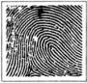  Ulna |   Double Loop Whorl | 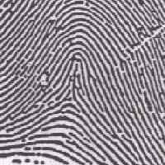  Tented
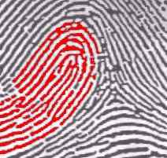  Radial |   Accidental Whorl | 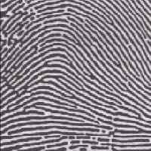  Plain
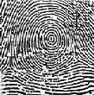
Plain Whorl
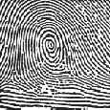

Central Pocket Whorl
 | Loops | Arches | Whorls
Class (number)
Class (%)
Population (%) | 65 | 5 | 30
Now draw a graph of the class results

Draw the whole population on the same graph to compare

- Are the class results the same as for the whole population? ...........................................................................................................................
- If not why not? ………………………………………………………………..

